THE PRESIDENT’S OFFICE
REGIONAL ADMINISTRATION AND LOCAL GOVERNMENT
NAMANGA SECONDARY SCHOOL

FORM FOUR PRE-MOCK EXAMINATION
31 GEOGRAPHY
TIME: 3 Hours April 2025

INSTRUCTIONS
- This paper consists of sections A, B and C, with total of eleven (11) questions.
- Answer all questions in section A and B and any two (2) questions from section C.
- Section A carries sixteen (16) marks, section B fifty-four (54) and section C carries thirty (30) marks.
- Map extract of ILONGA (Sheet 265/2) is provided.
- Programmable calculators, cellular phones and any unauthorised materials are not allowed in the examination room.
- Write your examination number on every page of your answer sheet.

SECTION A (16 MARKS)
Answer all questions in this section.
- For each of the items (i) – (x), choose the correct answer from among the given alternatives and write its letter in the answer booklet (s) provided.
  - Jackline is not aware that the Earth rotates on its own axis from west to east. You want to educate her, which factor among the following will prove to her that the Earth rotates in that way
    - During the night stars are fixed at one position but are in motion
    - Circumnavigation of the Earth
    - Aphelion and perihelion
    - The varying length of day and night
    - When moving in vehicles objects move in opposite direction
  - When digging a well, as a geographer, you had to go deep until you reach the underground layer of water-bearing permeable rock. What is that layer?
    - Aquifer
    - Aquiclude
    - Hard pan
    - Mantle layer
    - permeable rock
  - Seypalm is the animal keeper who keeps animals while moving seasonally with her cattle from low land areas to high land area to find water and pastures. What is that system applied by Seypalm?
    - Zero grazing
    - Sedentary
    - Semi-nomadism
    - nomadism
    - Transhumance

  - Kadege and Anna were debating on the section of a river characterized by a sharp v-shaped valley and interlocking spurs. As you are familiar with that, select the correct answer to educate them.
    - The old stage
    - The middle stage
    - The young stage
    - The mature stage
    - The young and middle stage
  - Suppose you want to carry out a field study on the atmospheric conditions suitable for growth of maize on a village farm. What are the best weather components you would consider?
    - Rainfall and wind
    - Rainfall and could cover
    - Moisture and sunshine
    - Rainfall and temperature
    - Pressure and humidity
  - The Tanzanian Meteorologists announced that the temperature of Morogoro, 100m above the sea level, is 29℃. What will be the temperature of Dodoma 800m above sea level?
    - 33.2℃
    - 20.8℃
    - 32℃
    - 24.8℃
    - 4.2℃
  - Your Geography teacher has planned to take you as his Geography student to visit European countries during the summer season; which month would you advise him to go?
    - January
    - September
    - December
    - March
    - June

- Tourists reported enjoying the temperature of Ihefu wetlands in Mbeya at 1500 meters above the sea level, which is 32ºC. They also planned to travel from Ihefu to Unguja in Zanzibar, which is at the sea level. What might be the temperature experienced by the tourists in Zanzibar?
  - 23⁰C
  - B. O.6⁰ C
  - C. 9⁰ C
  - D. 41⁰ C
  - E.19⁰ C
- When the form three students of Seypalm Secondary School were coming back from a tour, they saw a valley with water. After a short distance they saw a vertical hole where water disappears into the ground beneath. What is the name of the feature they saw that is associated with river erosion?
  - Dry valley
  - Swallow holes
  - Grikes and Clints
  - Doline
  - A swamp
- The national census involves counting people wherever they are on the day of enumeration. What is that kind of census called?
  - De jure
  - Quinquennial
  - De facto
  - Vital registration
  - Decennia
- Match the descriptions in LIST A with the correct item in LIST B by writing the letter of the correct response beside the item number in the answer booklet (s) provided.
LIST A | LIST B
- The term corrasion is also known as------------  - The lower course of the river is also known as------  - ------and ------ are the main features of the river that are formed in the middle course of a river.  - ----- are deep and narrow elongated steep sided valley or troughs formed as a result of vertical erosion of a river.  - ------is the main function of the river during the lower course.  - -------is the crescent shaped lake that is formed when the river meanders cut off from the main stream in the flood plain. | - An ox-bow lake  - Gorge  - Corrasion  - Old stage  - Delta lake  - Canyons  - Mature stage  - Deposition  - Rapids, Meanders  - Yong stage  - Transportation  - Abrasion  - Erosion  - Running water  - Meanders, Bluffs

SECTION B (54 MARKS)
Answer all questions in this section
- Study carefully the map extract of Ilonga sheet 265/2 and answer the following questions:
(a)Calculate distance of the feature from grid reference 506963 to 642040 in kilometers
(b) Compute the area covered with season swamp in the mapped area in kilometer square
(c) Change the map scale in to statement scale
(d) The mapped area has different opportunities; mention four economic activities and give one evidence for each
- Study carefully the data provided for the production of sisal in Kilwa and then answer the following questions:
YEARS | 2003 | 2004 | 2004 | 2005 | 2006
PRODUCTION (000 TONNES | 70 | 160 | 120 | 210 | 185

- Write any four procedures which might be used to draw the graph above
- Present the data above by deviation line graph
- Write down any other two methods which can be used.
- Research is a science because it follows the respective relevant steps. While all steps are supposed to be followed carefully, the third step is important as it helps researchers to think about outcome of the research.
- What is the step
- Explain the step motioned in (a) above
- Describe the advantage of the step in (a) above
- Suggest the next step
- Sir Palm is a Geography teacher at Seypalm Secondary school. One day he taught his students theoretically on how to conduct a survey and several days later he wanted them to do it practically, whereby he told them to collect information that would help them to draw the map of their School.
- What type of survey would they be carrying out?
- Propose three measuring equipment they would use.
- Explain three (3) obstacles that would possibly face them when collecting data.
- On planet Earth there are different geographical events which are occurring, the most common event occurs every year on 1st June. This event is well known by all geographers and people in the European countries.
- Name the event which occurs on that date.
- Explain the main causes of the event named in (a)
- Briefly explain what happens in European countries during the event.

- Carefully study the photograph below then answer the questions that follows:
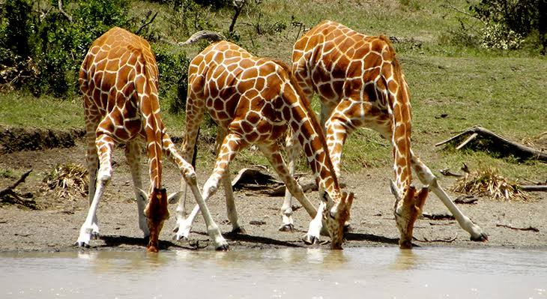
- Name the type of photograph
- Identify what is seen at the foreground of the photograph.
- With evidence from the photograph, suggest the economic activity that might be taking place in the area.
- Mention any three advantages and three disadvantages of the activity mentioned in (c) above.

SECTION C (30 MARKS)
Answer any two (02) questions from this section
- The late President of Tanzania, Dr. John Pombe Magufuli, supported construction of the Mwalimu Nyerere dam for Hydro Electric power production in the Rufiji river basin. What were the criteria used by the late President on deciding to construct the dam in Rufiji and not in the capital city- Dodoma? (Six points)
- Global population is said to be unevenly distributed. Using Tanzania as an example, account for the uneven population distribution in Tanzania. Give six points.

- Shauri’s grandmother believe that studying of Geography in the current globalized world is just a wastage of time since each and everything can be accessed through social networks, Televisions, and Internets. As a Geography student, convince Shauri’s grandmother with proof that studying Geography is significantly important in our daily life. Give six points.

